|  |
| --- |
| **Activity 1** |
| **Software Deployment** |
| DVD Search Application |

|  |
| --- |
| Jose Rico Imbang  05/12/2020 |

# TABLE OF CONTENTS

Project Management Software 1

Software Development Methodology 1

Source Control System 1

Collaboration Software 1

Link to the Source Control System 2

Link to the Collaboration Environment 2

## Project Management Software

The project management software that will be used is Microsoft Project. It is an easy choice since it is one of the most popular project management software so learning how to use it is as easy as searching the web. The application is designed to assist project managers in developing plans, assigning resources to tasks, tracking progress, managing budgets and analysing workloads.

## Software Development Methodology

The software development methodology that will be utilised is Scrum. With Scrum, a product owner creates a product backlog, a prioritise wish list. During sprint planning, the team pulls a chunk from that list and decides how to complete it. The team has a set timeframe, the sprint, to complete their work. They meet in a daily scrum to keep the work moving forward. The scrum master keeps the team focused along the way. At the end of the sprint, the work should be potentially shippable. The team then conducts a sprint review on the product and a retrospective on the process. They then choose the next chunk of the backlog and the cycle repeats.

## Source Control System

Git will be used for this project. Git is used to monitor the changes that are made when developing an application. This is extremely helpful especially in a team where different members work together. Let’s say a team of two is working on a project. The first programmer writes his own code while the other writes his own. By using Git, they are able to keep a copy of the original file while both programmers are adding some features on it. In case one of them doesn’t like the new feature, they can go back to the original file or add the feature that they like. Then from here, they can continue the development.

## Collaboration Software

With Trello, you can see who’s doing what and what needs to get done. The Trello board helps you organise information and tasks and see what is getting done. It is made up of lists. They can be steps in a workflow, categories, etc. Cards can be added to the lists to keep track of everything you need to do or remember like features to add to the application, bugs to fix, meeting to attend, etc. You can drag cards across lists to show progress or just to organise them. Click to open cards, where team members can add details like checklists, due dates, files, and comments. The boards can be shared with co-workers, classmates, etc.

## Link to the Source Control System

[Click here to go to the source control](https://github.com/Rico-Jose/SoftwareDeployment/tree/main/Project)

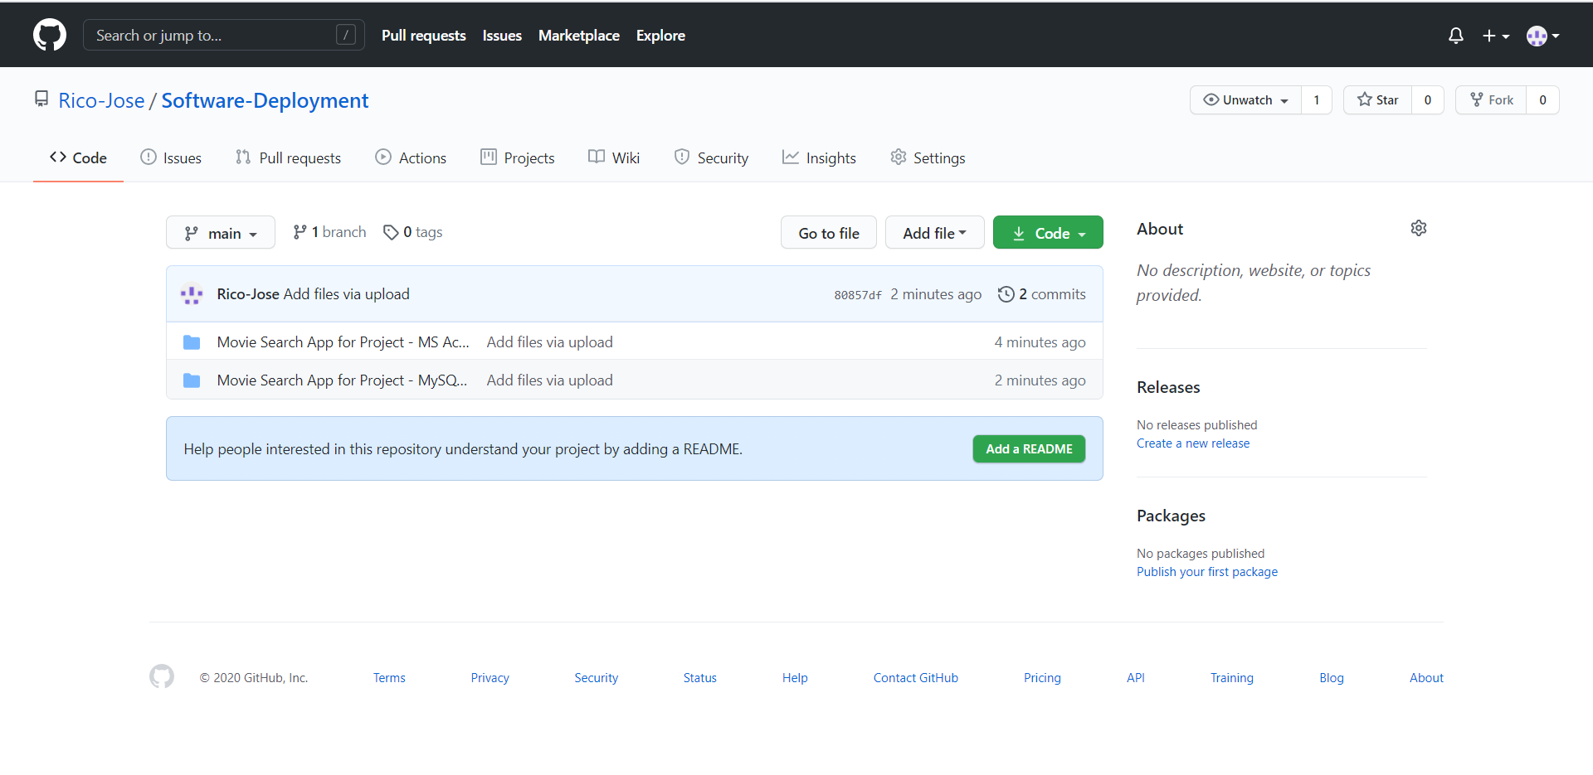

## Link to the Collaboration Environment

[Click here to go to the collaboration](https://trello.com/b/dxB3RF4r/dvd-search-app)

